Write a query to display the username and password of all customers. Give an alias name as USERNAME and PASSWORD. Sort the result based on the Username in ascending order.

Username and password is generated as below

USERNAME: concatenate the customer name with customer  id.

PASSWORD: concatenate first 3 character of customer name with last 4 digits of customer phone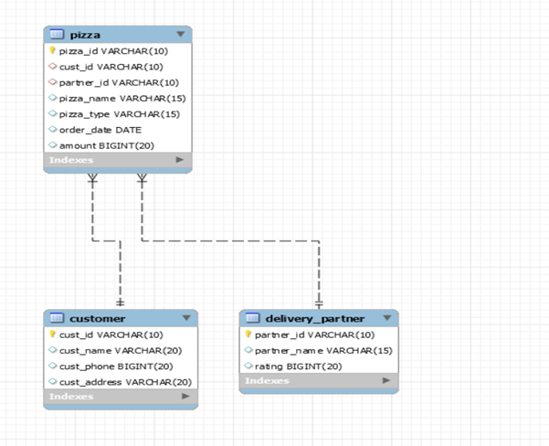

For Example:

cust_id -C001

cust_name – Deepak

cust_phone -7892298767

Output:

USERNAME- DeepakC001

PASSWORD-Dee8767

Design Rules:

1. Use the rules to generate Username and Password.

3.  Do not change the name of the column. Please use as per the design rules.

4. Order of the output columns: Username,Password.

5.Sort the results in Ascending Order of Username